cgx@cgx:/usr/bin$ cp -r /usr/src/cudnn_samples_v7/ $HOME

cgx@cgx:/usr/bin$ cd $HOME/cudnn_samples_v7/mnistCUDNN

cgx@cgx:~/cudnn_samples_v7/mnistCUDNN$ sudo make clean && make

rm -rf *o

rm -rf mnistCUDNN

Linking agains cublasLt = true

CUDA VERSION: 10020

TARGET ARCH: x86_64

HOST_ARCH: x86_64

TARGET OS: linux

SMS: 30 35 50 53 60 61 62 70 72 75

/usr/local/cuda/bin/nvcc -ccbin g++ -I/usr/local/cuda/include -I/usr/local/cuda/include -IFreeImage/include -m64 -gencode arch=compute_30,code=sm_30 -gencode arch=compute_35,code=sm_35 -gencode arch=compute_50,code=sm_50 -gencode arch=compute_53,code=sm_53 -gencode arch=compute_60,code=sm_60 -gencode arch=compute_61,code=sm_61 -gencode arch=compute_62,code=sm_62 -gencode arch=compute_70,code=sm_70 -gencode arch=compute_72,code=sm_72 -gencode arch=compute_75,code=sm_75 -gencode arch=compute_75,code=compute_75 -o fp16_dev.o -c fp16_dev.cu

g++ -I/usr/local/cuda/include -I/usr/local/cuda/include -IFreeImage/include -o fp16_emu.o -c fp16_emu.cpp

g++ -I/usr/local/cuda/include -I/usr/local/cuda/include -IFreeImage/include -o mnistCUDNN.o -c mnistCUDNN.cpp

/usr/local/cuda/bin/nvcc -ccbin g++ -m64 -gencode arch=compute_30,code=sm_30 -gencode arch=compute_35,code=sm_35 -gencode arch=compute_50,code=sm_50 -gencode arch=compute_53,code=sm_53 -gencode arch=compute_60,code=sm_60 -gencode arch=compute_61,code=sm_61 -gencode arch=compute_62,code=sm_62 -gencode arch=compute_70,code=sm_70 -gencode arch=compute_72,code=sm_72 -gencode arch=compute_75,code=sm_75 -gencode arch=compute_75,code=compute_75 -o mnistCUDNN fp16_dev.o fp16_emu.o mnistCUDNN.o -I/usr/local/cuda/include -I/usr/local/cuda/include -IFreeImage/include -L/usr/local/cuda/lib64 -L/usr/local/cuda/lib64 -lcublasLt -LFreeImage/lib/linux/x86_64 -LFreeImage/lib/linux -lcudart -lcublas -lcudnn -lfreeimage -lstdc++ -lm

cgx@cgx:~/cudnn_samples_v7/mnistCUDNN$ ./mnistCUDNN

cudnnGetVersion() : 7605 , CUDNN_VERSION from cudnn.h : 7605 (7.6.5)

Host compiler version : GCC 8.4.0

There are 1 CUDA capable devices on your machine :

device 0 : sms 16 Capabilities 7.5, SmClock 1560.0 Mhz, MemSize (Mb) 3911, MemClock 4001.0 Mhz, Ecc=0, boardGroupID=0

Using device 0

Testing single precision

Loading image data/one_28x28.pgm

Performing forward propagation ...

Testing cudnnGetConvolutionForwardAlgorithm ...

Fastest algorithm is Algo 0

Testing cudnnFindConvolutionForwardAlgorithm ...

^^^^ CUDNN_STATUS_SUCCESS for Algo 0: 0.010976 time requiring 0 memory

^^^^ CUDNN_STATUS_SUCCESS for Algo 1: 0.030976 time requiring 3464 memory

^^^^ CUDNN_STATUS_SUCCESS for Algo 2: 0.038912 time requiring 57600 memory

^^^^ CUDNN_STATUS_SUCCESS for Algo 5: 0.054816 time requiring 203008 memory

^^^^ CUDNN_STATUS_SUCCESS for Algo 7: 0.114496 time requiring 2057744 memory

**Cublas failure**

**Error code 0**

**gemv.h:77**

**Aborting...**

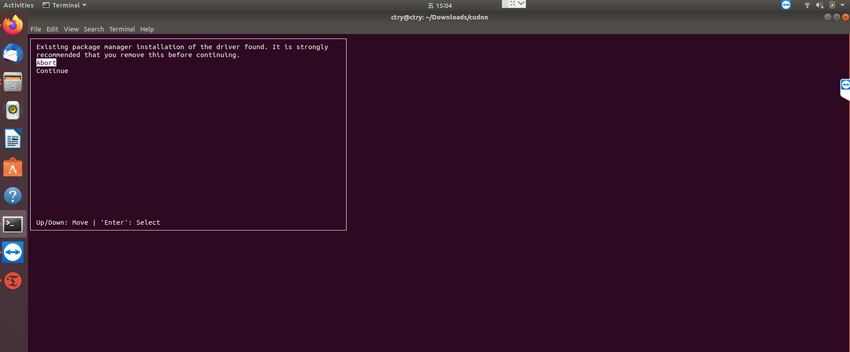

**缺少依赖库**

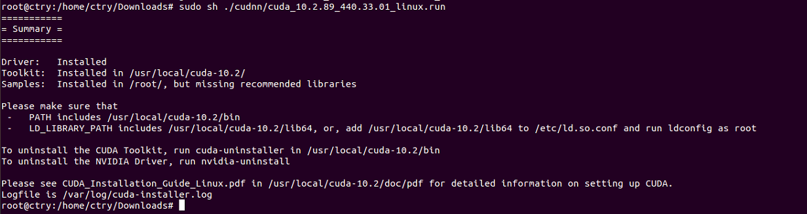

**使用apttitude进行升级安装**

**sudo apt-get install freeglut3-dev build-essential libx11-dev libxmu-dev libxi-dev libgl1-mesa-glx libglu1-mesa libglu1-mesa-dev**

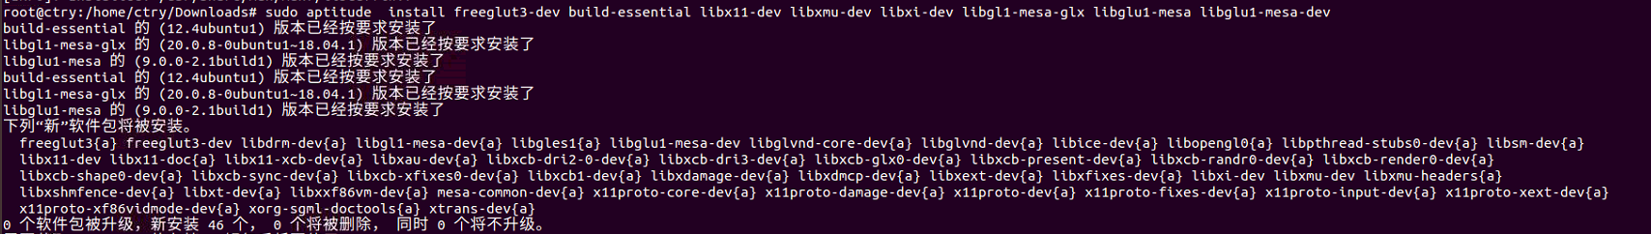

**安装好之后，nvcc -V 没有反应，是因为还需要配置环境变量**

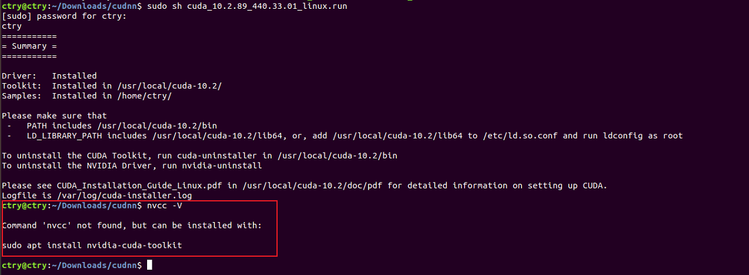

**根据安装的提示来修改环境变量**

**Driver: Installed**

**Toolkit: Installed in /usr/local/cuda-10.2/**

**Samples: Installed in /home/ctry/**

**修改 sudo vim ~/.bashrc 在末尾添加**

**export PATH=/usr/local/cuda-10.2/bin:$PATH**

**export LD_LIBRARY_PATH=/usr/local/cuda-10.2/lib64:$LD_LIBRARY_PATH**

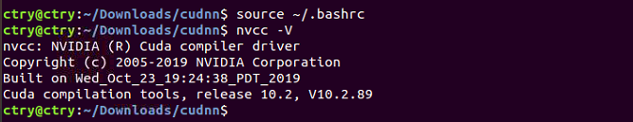

**以上就安装好了cuda**

**接下来就是安装cudnn**

**下载这几个文件**

**tar -xvf cudnn-10.2-linux-x64-v7.6.5.32.tgz**

**sudo cp cuda/include/cudnn*.h /usr/local/cuda/include**

**sudo cp cuda/lib64/libcudnn* /usr/local/cuda/lib64**

**sudo chmod a+r /usr/local/cuda/include/cudnn*.h /usr/local/cuda/lib64/libcudnn**

**测试用例**

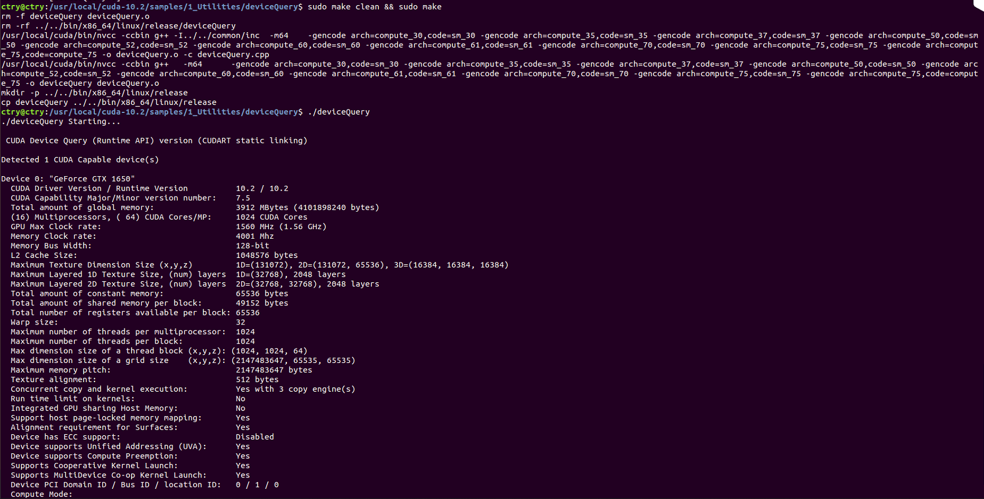  
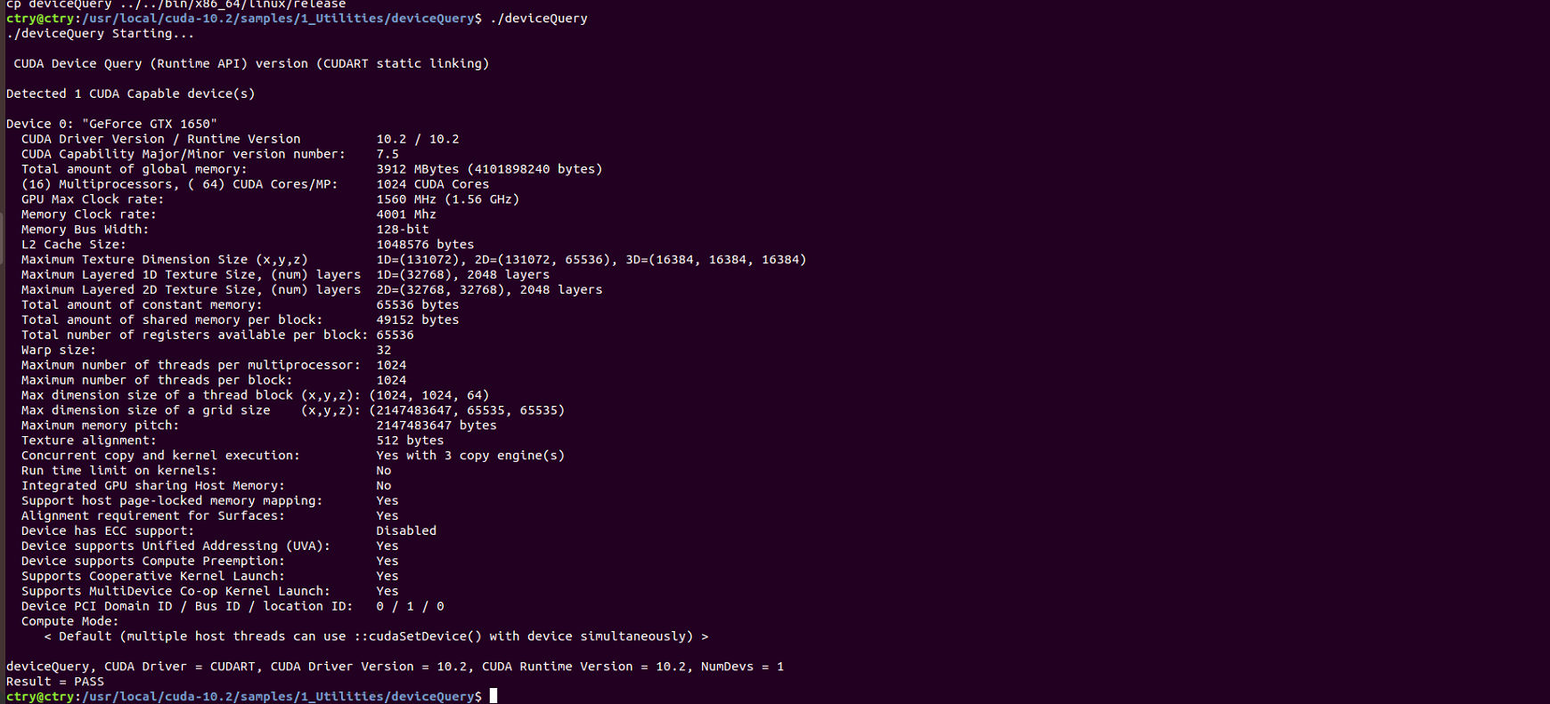

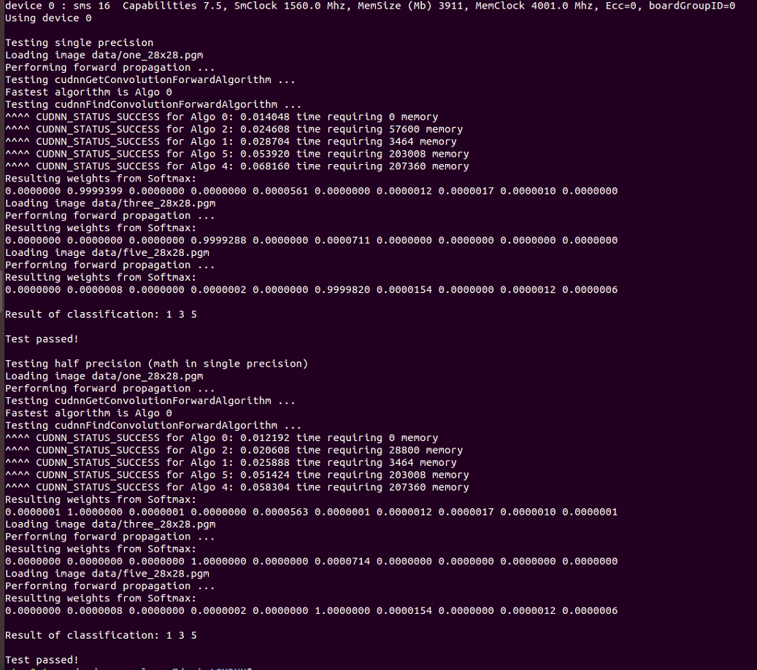

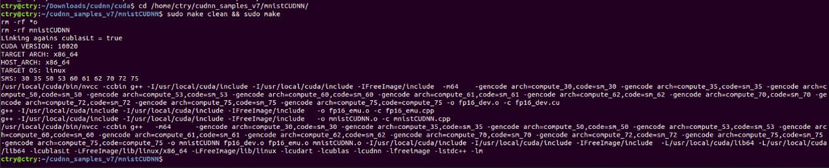

git init

git config --global user.name "cty lab"

git config --global user.email "853943934@qq.com"

Github 生成秘钥

ssh-keygen -t rsa -C [XX@XX.com](mailto:XX@XX.com)

cat ~/.ssh/id_rsa.pub

git add .

git commit -m “你想要说的标记”

git push origin XX远程分支名字

git branch --set-upstream-to=origin/feature/dev feature/dev

git remote add origin <https://github.com/CcTtry/mathcm.git>

建立关联